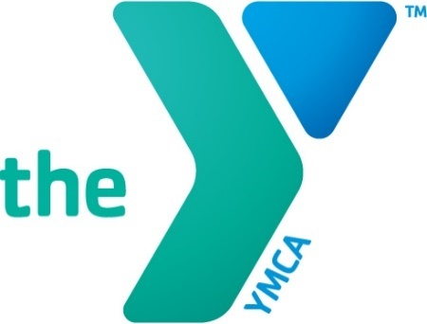

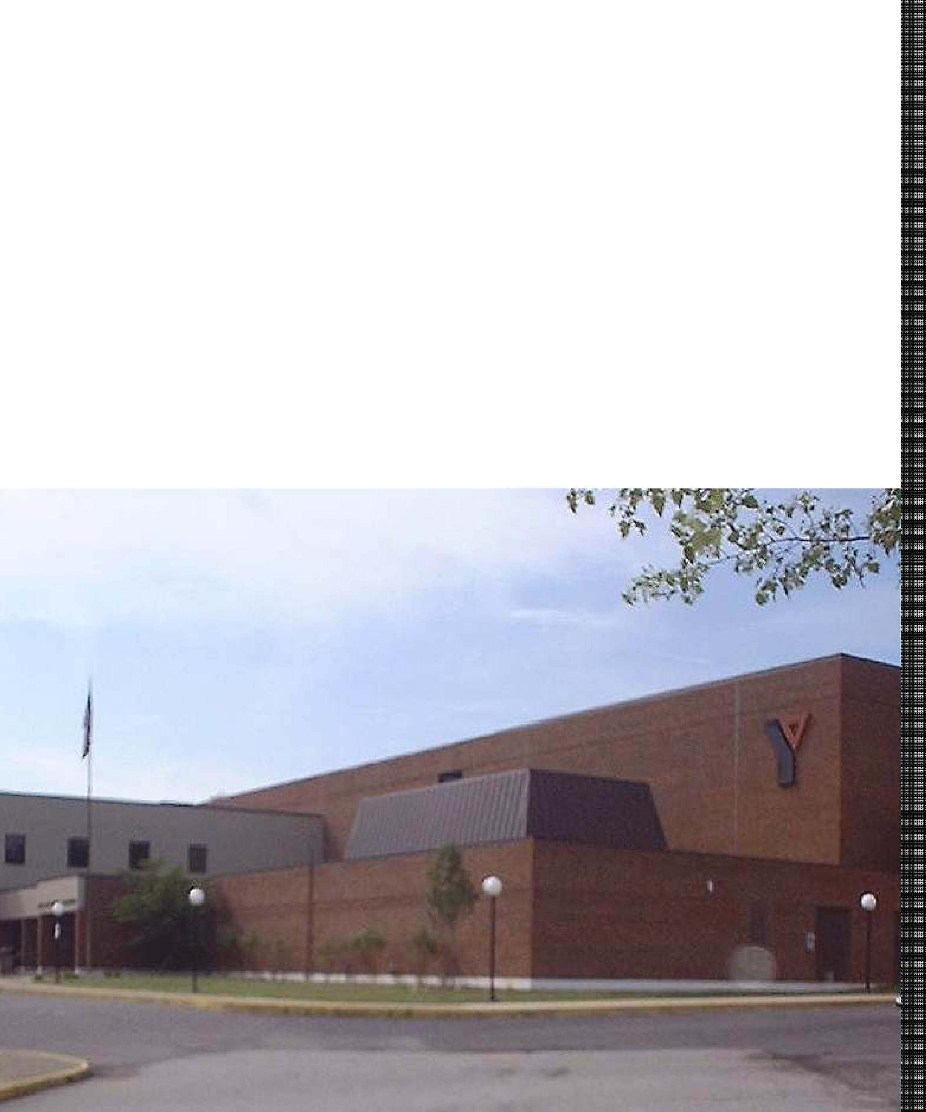

MEMBER HANDBOOK

ASHLAND AREA

YOUNG MEN’S CHRISTIAN ASSOCIATION



[www.ashlandareaymca.org](http://www.ashlandareaymca.org/)

Find us on Social Media under

Ashland Area YMCA

FaceBook, Twitter, Instagram

Any person who supports the purpose of the Ashland Area YMCA may become a member of this corporation in accordance with such provisions as may be established by the Board Of Directors, and shall so continue to be a member, provided that said person is otherwise in compliance with all requirements for continuing membership, unless the Board Of Directors or its authorized agent concludes, in its sole discretion, that a member has failed to live up to the standards and commitments of being a member of this YMCA.

Specifically, the Ashland Area YMCA reserves the right to deny access or to terminate existing membership, to any person who has been convicted of any crime involving sexual abuse, is or has been a registered sex offender, or has ever been convicted of a felony offense relating to the use, sale, possessions, or transportation of illegal drugs.

In the event that the Board of Directors determines that a previously existing membership to the Ashland Area YMCA should be terminated pursuant to the above guidelines, the YMCA shall notify the member of its actions and the reasons therefore, and shall make a pro rata refund of any prepaid membership dues or fees.

# FACILITY HOURS

Monday thru Friday

5 am-10 pm

Saturday

6 am-8 pm

Sunday

1 pm-8 pm

# UNSUPERVISED CHILDREN IN THE FACILITY

Any youth member under the age of 11 years old in the YMCA building or grounds are required to be under the supervision of a parent or adult guardian, or registered and participating in a supervised YMCA program or activity. The YMCA is not responsible for any child not signed into a supervised YMCA program.

# HOLIDAY HOURS

The Ashland Area YMCA honors the following holidays:

* Easter-Closed
* Memorial Day-Close at noon
* 4th of July-Close at noon
* Labor Day-Close at noon
* Thanksgiving-Closed
* Christmas Eve-Close at noon early;
* Christmas Day-Closed
* New Year’s Eve-Close at noon
* New Year’s Day-Open at 10:00 AM.

# CLOSING POLICY

If the facility needs to be closed due to inclement weather, power outages or an act of God, refunds will not be issued for membership or fee-based classes.

# MEMBERSHIP CLASSIFICATIONS

Household memberships include two adults living in the household with any child(ren) residing in home under age of 18. You may be asked for proof of residence.

Household Health Center memberships include access to the Health Centers for two adults living in the household and basic membership access for any child(ren) living in the home under the age of 18.

Adult memberships are available for anyone 18 and over. We offer the Basic and the Health Center option.

College memberships are available at a 50% discount for anyone carrying at least 6 credit hours. You will be required to submit a current college schedule.

Youth memberships consists of any person under the age of 18 years old. There are no health center privileges for Youth. If a person has turned 18 and shows proof they are still in high school, they may still purchase a youth membership.

Senior Citizen discount of 20% is available for any membership for an individual over 65 years of age. Discounts will not be retroactive. You may inform us up to thirty days in advance if you are a current member wishing to receive the discount.

Foster Children & Exchange Students.may be added to the family membership unit after proof of status of that child is provided to the YMCA. When that child is no longer in the home it is the responsibility of the Parent to contact the YMCA and have the child removed from the membership.

**Current prices may be obtained at the Member Services Desk.

**BANK/ELECTRONIC DRAFT**

Upon joining, payment of the first month’s pro-rated dues is required. With your authorization, an automatic monthly withdrawal will begin the following month of membership from either your checking/savings account or debit/credit card. **This is an ongoing deduction that remains in effect until cancelled in writing at least 15 days prior to your draft date.** Bank/Electronic Drafts will draft on or about the 1st or 15th of every month. Payment of fees must be kept current, or membership will be subject to cancellation.

# ANNUAL PAYMENTS

You may pay your membership in full for the year or you may make semi-annual or quarterly payments.

# PAYROLL DEDUCTION

Many employers offer the convenience of letting you have your membership dues deducted directly from your paycheck.

Contact the YMCA or your employer to see if your company participates in this program.

# SCHOLARSHIP ASSISTANCE

The Ashland Area YMCA is a not-for-profit health and human services organization committed to helping people grow in spirit, mind and body.

We believe that memberships should be available to everyone regardless of ability to pay. The YMCA offers financial assistance that is designed to fit each individual’s financial situation.

To apply for scholarship assistance, please ask for an application form from the Member Services Desk. Please allow up to 30 days to process your application. Interviews are done once a month.

# MEMBERSHIP CANCELLATION

**CANCELLATIONS ARE NOT ACCEPTED BY PHONE FOR ANY REASON OR FOR ANY MEMBERSHIP TYPE.**

**BANK/ELECTRONIC DRAFT MEMBERSHIPS**

Membership must be cancelled **in person** 10 days prior to your monthly draft date or by **registered mail.**

If you are mailing in your membership cancellation, please include the following:

* + Your membership card;
  + A letter stating why you are canceling your membership;
  + Your current contact information.

Your request must be received by the 5TH day of the month to be cancelled before the 15th draft date.

Mail the cancellation letter and your memberships cards via registered mail to:

Ashland Area YMCA 3232 Megan Neyer Way

Ashland, KY 41102

Attn: Missy Griffith

Your membership will continue until you personally come in and cancel the membership or until it is received by the YMCA via registered mail.

**PAYROLL DEDUCTION**

If you signed up for payroll deduction at the YMCA, then you need to cancel at the YMCA front desk. If you signed up with the Human Resources Department of your employer, you will need to cancel your membership there.

**PAID IN FULL OR TEMPORARY MEMBERSHIPS**

If you paid for your membership in full, semi-annually or quarterly, there are no refunds given unless you have a doctor’s excuse stating a medical reason that you cannot attend the YMCA or unless you provide proof that you have been transferred or moved over 50 miles away from the facility.

# GUEST PASSES

Daily guest passes are available upon presentation of a valid photo ID with current address.

* + Adult guest passes are

$10 and this does include the health center privileges;

* + Youth guest passes are

$5;

* + Family guest passes are

$20, this does include the health center privileges for adults over 18;

* + Senior citizen guest passes are $5;
  + Military guest passes are

$2 with proof of military status;

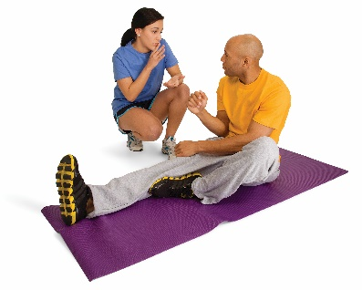

**ACCESS TO FACILITY**

All Ashland Area YMCA members must scan their membership card to be admitted to the facility. Forgot your card? You may be admitted 3 times per year free of charge, after that you will be charged an administrative fee of $1 per visit or you may purchase a replacement card. Lost and found cards are kept at the Member Services Desk. You may also download our Mobile App “Ashland Area YMCA” and download your card to the app for easy access.

Loan of membership card subjects the member to loss of membership.

# REPLACEMENT CARDS

If you misplaced your membership card, you may purchase a new one for $5 at the Member Services Desk.

# CELL PHONE/CAMERA POLICY

Due to the advances in video and photo technology and for the privacy of our members and guests:

* + Cell phones MAY NOT be used in locker rooms, but may be used in the public areas of the facility.

# LOST AND FOUND

The Ashland Area YMCA has a Lost & Found for the convenience of our members. All valuable items are placed in the safe and can be claimed at the Member Services Desk during daytime hours. Non-valuable items may be claimed during regular business hours at the Y Mart.

# AEDS (AUTOMATED EXTERNAL DIFIBRILLATOR) & FIRST AID SUPPLIES

The YMCA is equipped with an AED. The Automated External Defibrillator is located at the Member Services Desk. All YMCA is CPR certified and trained to use the AED should the need arise. First Aid supplies are available at the Member Services Desk.

# TOBACCO & DRUG FREE ENVIRONMENT

In keeping with YMCA health and fitness advocacy, drugs, vapes or tobacco of any kind are not permitted. The Ashland Area YMCA premises; including the parking lot, is smoke free.

# PARKING LOT

The Ashland Area YMCA is not responsible for loss or damage to vehicles in the Y’s parking lot.

# Y MART

The Y Mart is a place to serve our member’s needs. The Y Mart takes care of locks, daily towel rental, racquetball equipment, merchandise, refreshments, toiletries, etc. To utilize the rental of equipment (locks, towels, racquetball equipment) you must leave your membership card with the attendant.

# FACILITY RENTALS

The YMCA will offer rentals to organizations, groups, and individuals to rent out single rooms or parts of the facility. The YMCA reserves the right to deny rental if they believe it to be detrimental to the mission of the YMCA.

Contact the Member Services Desk for information on Birthday Parties, showers, conferences, etc. Contact Max Hunter, Athletic Director for information on renting the facility for overnighters.

# LOCKER ROOMS

Daily locker rental is included in your membership fee or daily guest fee. Locks are available at the Y Mart. Annual locker rental is available on a first come first served basis.

We strongly encourage you to leave your valuables at home. The YMCA is not responsible for lost or stolen items. If you cannot leave your valuables at home, please use the individual wallet lockers located in the lobby.

The Boys and Girls locker rooms are available for youth memberships and family memberships that do not have health center privileges. Children under the age of 6 may go to the locker room with their parents, but after they turn 6 they must go to the gender correct locker room.

The Women’s Health Center and Men’s Health Center locker rooms are only available to members with health center privileges. No person under the age of 18 is permitted in the health center locker rooms or workout areas.

No exceptions.

The Women’s and Men’s Health Centers have available a whirlpool, sauna and steam room as well as private workout areas.

# ATTIRE

All attire worn in the YMCA must be appropriate and consistent with the YMCA mission. Any attire deemed inappropriate by the YMCA staff will be disallowed immediately.

# CLASS REGISTRATION

Class registration will be held one week prior to the date the class begins. Some classes are limited in size. NO PHONE OR E-MAIL

registrations will be accepted. Classes may be cancelled due to low enrollment.

# PHOTOS OR VIDEOS

There will be times when the YMCA will take photos or videos of programs or individuals for promotional purposes. We may or may not be using a photo of you or a family member. If you do not want your picture used for promotional purposes, please let us know.

# CODE OF CONDUCT

The YMCA is committed to providing a safe and welcoming environment for all members and guest. To promote safety and comfort for all, all individuals are asked to act appropriately at all times when in our facility or participating in our programs.

We expect persons using the YMCA to act maturely, to behave responsibly, and to respect the rights and dignity of others. Our Members Code of Conduct outlines prohibited behavior, but the actions listed below are not an all-inclusive list of behaviors considered inappropriate in our facilities or programs.

* + Using or possessing alcohol or illegal chemicals on YMCA property;
  + Smoking on the YMCA premises;
  + Carrying or concealing a weapon or any device or object that may be used as a weapon;
  + Use of cell phones in the shower and locker room areas;
  + Use of any video/picture taking equipment, including camera phones, in YMCA’s shower or locker rooms;
  + Harassment or intimidation by words, gestures, body languages, or any type of menacing behavior;
  + Physical contact with another person in an angry, aggressive or threatening way;
  + Verbally abusive behavior, including angry or vulgar language, swearing, name-calling, or shouting;
  + Sexually explicit conversation or behavior: any sexual contact with another person;
  + Inappropriate, immodest, or sexually revealing attire;
  + Theft or behavior that results in the destruction or loss of property;
  + Loitering within or on the grounds of the YMCA.

# INAPPROPRIATE BEHAVIOR

In the event that someone is found to be displaying inappropriate behavior, not following rules, abusive to YMCA staff or other persons while in the facility or at a YMCA event, the following procedures will be followed:

1. Individual will be taken to the Member Services Desk where parents will be called and notified of incident.
2. Membership card will be confiscated for the assigned period of time individual is excluded from facility;
3. General policy for time period exclusion:
   1. 1st offense-3 days
   2. 2nd offense-1 week
   3. 3rd offense-2 weeks
   4. 4th offense-1 month
   5. 5th offense-6 months

The length of exclusion can be altered to fit the severity of the incident.

1. When someone is excluded from the YMCA, it includes any and all participation in YMCA activities. They are not allowed inside the building.

# YMCA NURSERY & FUN FACTORY

Enjoy a workout, or take a class while we watch your child.

Service is provided free of charge for YMCA members (the child must also be a member) while using the YMCA. Children ages 3 months to 5 years are permitted to use the nursery for a 2-hour maximum time limit and ages 5-10 are permitted to use the Fun Factory. Nursery and Fun Factory are services provided for children that are part of a **Family** membership only.

**COMPLAINTS/GRIEVANCE**

Written Complaint Required for Formal Process

Verbal complaints are encouraged, particularly for issues that may be easily

and expeditiously resolved, but a written complaint is required to initiate this

grievance process. (YMCA Grievance Form)

To ensure a timely and effective response, complaints should include the

following information to the extent possible:

1) The name(s) of individuals(s) involved;

2) The date(s) the behavior occurred;

3) The name(s) of any known witness(es);

4) A summary of the conduct meriting the grievance including:

a. The behavior complained of and/or the alleged policy or legal

violation(s);

b. Direct quotes when relevant and available; and

c. Any relevant documentation.

5) The remedy sought by the employee making the complaint.

Timeline

Consumers or parents/guardians who themselves have a complaint or who are

aware of behavior meriting a complaint, must provide the above-described

written complaint via email to the Ashland Area YMCA Executive Director within 24 hours. Complaints will be addressed within 5-10 business days. The

Executive Director will meet with the consumer or parent/guardian to hear the

concern and attempt to resolve the complaint within 10-15 business days

unless it becomes a legal issue as this may exceed the 10-15 business days.

Following that meeting, the Executive Director will provide a brief written

response to the consumer or parent/guardian who brought the complaint no

later than 10-15 business days.

If the consumer or parent/guardian is not satisfied with the written response,

the individual who brought the complaint may submit an appeal to the YMCA

Board. The YMCA Board may meet with the consumer or parent/guardian to

hear their concern and attempt to resolve the complaint in 10-15 business

days.

Following that meeting, the Executive Director and the YMCA Board will

provide a written response to the consumer or parent/guardian who brought

the complaint no later than 10-15 business days

The YMCA Board will decide on the final appeal is the final arbiter of grievance

matters at this organization.

Investigation

The Ashland Area YMCA Executive Director, designated to investigate and/or

YMCA Board who will hear and decide on the final appeal will thoroughly

investigate the issues raised in the grievance and will protect the privacy and

confidentiality of all parties involved to the extent possible by law. All parties

must cooperate with the investigation.

If the organization determines a violation of policy or law has occurred, the

organization will take appropriate action, up to and including termination and

notification of external authorities.

Retaliation

This organization strictly prohibits retaliation against consumers and/or

parents/guardians for reporting, filing, testifying, assisting or participating in

any manner in any investigation, proceeding or hearing conducted by the

organization or a federal or state law enforcement agency or court. Consumers

and/or parents/guardians should report any suspected retaliation to the

Executive Director will receive these concerns, the Executive Director and/or

YMCA Board will decide on the final appeal immediately after becoming aware

of it. Any report of retaliatory conduct will be objectively, timely and thoroughly

investigated. If a report of retaliation is found to be valid, the organization will

take appropriate remedial action, up to and including discharging the

individual(s) responsible. This organization will not retaliate against any

consumer or parent/guardian for raising a complaint and will not knowingly

permit retaliation by management or other employees.

**Ashland Area YMCA Policies & Procedures**

Revised:  06/19/2024

**Policy Name:** Grievance Policy

**Policy:** The Ashland Area YMCA believes consumers, and parents/guardians have valuable thoughts and insights to share regarding our operations. Accordingly, this organization encourages consumers and parents/guardians to share opinions, suggestions, concerns, questions and/or grievances about our policies, personnel, and/or other matters impacting the organization.

**Scope:**

In general, the best person initially to bring opinions, suggestions, concerns, and/or questions to is the Ashland Area YMCA Executive Director.  However, to the extent the concerns relate to the Ashland Area YMCA Executive Director, or to the extent a consumer or parent/guardian believes the Ashland Area YMCA Executive Director did not fully address a matter, consumers and parents/guardians may direct their opinions, suggestions, concerns, and/or questions to the next level of management or directly to the Ashland Area YMCA Board Chairman to hear/resolve grievances.

**Procedure:**

To remedy concerns that appear to have been ignored or unresolved after initial reporting, utilize this formal grievance procedure. This procedure provides for a timely, thorough and objective investigation of the following concerns:

Inappropriate Behavior by Employees/Volunteers.

Inappropriate Behavior by Consumers.

Retaliation; and/or; Whistleblower complaints.

**Written Complaint Required for Formal Process**

Verbal complaints are encouraged, particularly for issues that may be easily and expeditiously resolved, but a written complaint is required to initiate this grievance process. **(YMCA Grievance Form)**

To ensure a timely and effective response, complaints should include the following information to the extent possible:

1. The name(s) of individuals(s) involved;
2. The date(s) the behavior occurred;
3. The name(s) of any known witness(es);
4. A summary of the conduct meriting the grievance including:
   1. The behavior complained of and/or the alleged policy or legal violation(s);
   2. Direct quotes when relevant and available; and
   3. Any relevant documentation.
5. The remedy sought by the employee making the complaint.

**Timeline**

Consumers or parents/guardians who themselves have a complaint or who are aware of behavior meriting a complaint, must provide the above-described written complaint via email to the Ashland Area YMCA Executive Director within 24 hours.  Complaints will be addressed within 5-10 business days.  The Executive Director will meet with the consumer or parent/guardian to hear the   
concern and attempt to resolve the complaint within 10-15 business days unless it becomes a legal issue as this may exceed the 10-15 business days.

Following that meeting, the Executive Director will provide a brief written response to the consumer or parent/guardian who brought the complaint no later than 10-15 business days.

If the consumer or parent/guardian is not satisfied with the written response, the individual who brought the complaint may submit an appeal to the YMCA Board.  The YMCA Board may meet with the consumer or parent/guardian to hear their concern and attempt to resolve the complaint in 10-15 business days.

Following that meeting, the Executive Director and the YMCA Board will provide a written response to the consumer or parent/guardian who brought the complaint no later than 10-15 business days

The YMCA Board will decide on the final appeal is the final arbiter of grievance matters at this organization.

**Investigation**

The Ashland Area YMCA Executive Director, designated to investigate and/or YMCA Board who will hear and decide on the final appeal will thoroughly investigate the issues raised in the grievance and will protect the privacy and confidentiality of all parties involved to the extent possible by law.  All parties must cooperate with the investigation.

If the organization determines a violation of policy or law has occurred, the organization will take appropriate action, up to and including termination and notification of external authorities.

**Retaliation**

This organization strictly prohibits retaliation against consumers and/or parents/guardians for reporting, filing, testifying, assisting or participating in any manner in any investigation, proceeding or hearing conducted by the organization or a federal or state law enforcement agency or court. Consumers and/or parents/guardians should report any suspected retaliation to the Executive Director will receive these concerns, the Executive Director and/or YMCA Board will decide on the final appeal immediately after becoming aware of it.  Any report of retaliatory conduct will be objectively, timely and thoroughly investigated. If a report of retaliation is found to be valid, the organization will take appropriate remedial action, up to and including discharging the individual(s) responsible.  This organization will not retaliate against any consumer or parent/guardian for raising a complaint and will not knowingly permit retaliation by management or other employees.

**Policy Requiring Confidentiality of Reports**

The Ashland Area YMCA will protect the confidentiality of anyone who reports allegations or disclosures of abuse, or other violations of law or policy to the extent possible under law.

Legal and civil authorities (police, child or adult protective services) may require confidential information in order to investigate any report of illegal conduct but this does not eliminate the requirement to maintain confidentiality within the organization and its employees, volunteers, and consumers.

The organization will provide written communication of any changes to this policy to all employees, volunteers, consumers, and parents/guardians.

**Policy for Follow-Up with Individuals who Report Concerns or Complaints**

The Ashland Area YMCA is committed to creating a safe environment for our employees,

volunteers, and especially our youth and their parent/guardians. For that reason, we will

treat every concern or complaint with the utmost seriousness and provide a timely,

thorough, and objective response in every instance. When an individual shares a concern or

complaint they will be:

1. Given the time and attention necessary to allow them to share their thoughts in

person, if they feel comfortable doing so.

2. Thanked for sharing their concerns with the YMCA and for contributing to

maintaining a healthy and safe environment for everyone.

3. Advised that their concern is being taken seriously and that action will be taken.

4. Reassured that they have done the right thing by reporting and that their

communication is valued.

5. Informed, in general statements, of the steps that the YMCA will take in addressing

the matter.

6. Given contact information for someone in the YMCA with whom they can contact

should they become aware of additional information.

7. Provided regular updates of how the process is advancing.

8. Protected by the YMCA from any form of retaliation to the extent possible.

**Reporting**

For anonymous reporting, 24/7 HELPLINE **call 1-855-347-0751.**

<https://www.praesidiuminc.com/respond/>

This organization is committed to creating an environment where everyone is encouraged

to share their concerns and those concerns are taken seriously. To this end, we have

partnered with Praesidium to establish a helpline that is available to everyone (employees,

volunteers, parents/guardians, consumers, community members, etc.) 24 hours a day, seven days a week, 365 days a year.

**What is the Praesidium Helpline?**

The Praesidium Helpline is a consultation line anyone in the organization can call to discuss

observations of inappropriate behaviors, suspicious behaviors, policy violations, instances

of consumer-to-consumer sexual activity, and any other abuse prevention questions and

issues.

**What can you expect when you call?**

One of Praesidium’s experts will be ready to answer your call and gather any information

relevant to your concern or question. If the matter the caller shares, is one deemed to be

suspected or known sexual abuse, the caller will be instructed by Praesidium to immediately

call the civil authorities.

**What happens once you get off the call?**

Praesidium’s team of risk management experts comprised of social workers, attorneys, and

other professionals will staff the concern or situation and develop recommended responses

and next steps. Praesidium will then share the concern and the recommendations with

stakeholders at the organization.

**Grievance Form for Parents/Guardians and Consumers**

Individual Filing Complaint _______________________________________________________________

Role (i.e. Consumer or Parent/Guardian) ________________________________________________

Date of occurrence ___________                                  Time of occurrence: ___________

Other Individuals Involved/Witnesses to Complaint____________________________________________

Type of Complaint (select all that apply):

Inappropriate Behavior by Employees/Volunteers;

Inappropriate Behavior by Consumers;

Retaliation; and/or; Whistleblower complaints.

**Describe the situation:** What happened, where it happened, when it happened, who was involved, who was present, who was notified? If suspected abuse, was it reported to the State?

______________________________________________________________________________________________________________________________________________________________________________________________________________________________________________________________________________________________________________________________________________________________________________________________________

Has this situation ever occurred previously?   ____________________________________________

**Describe the remedy you seek.** Please list all remedies sought because of bringing this grievance. What would you like to see happen to solve this issue?

______________________________________________________________________________________________________________________________________________________________________________________________________________________________________________________________________________________________________________________________________________________________________________________________________

Submitted by: ___________________________________ Telephone number____________________

Location or organization: ______________________________________________________________________

Signature: ______________________________________   Date _________________________________

Reviewed by: ___________________________________

**\*Email completed form to scampbell@ashlandareaymca.org**